Record of Labels Printed

This form should be used in association with
Pharm/S105 – Production and control of clinical trial labels

IT IS THE RESPONSIBILITY OF ALL USERS OF THIS FORM TO ENSURE THAT THE CORRECT VERSION IS BEING USED

All staff should regularly check the R&D Unit’s website and/or Q-Pulse for information relating to the implementation of new or revised versions. Staff must ensure that they are adequately trained in the new procedure and must make sure that all copies of superseded versions are promptly withdrawn from use unless notified otherwise by the SOP Controller.

The definitive versions of all R&D Unit SOPs appear online. If you are reading this in printed form check that the version number and date below is the most recent one as shown on the R&D Unit website: https://www.research.yorkhospitals.nhs.uk/sops-and-guidance-/ and/or Q-Pulse

Form Reference: | Pharm/F105
Version Number: | 4.0
Author: | Courtney Cole
Implementation date of current version: | 12th October 2020

Approved by: | Name/Position: | Poppy Cottrell-Howe, Pharmacy Clinical Trials Manager
Approved by: | Signature: | 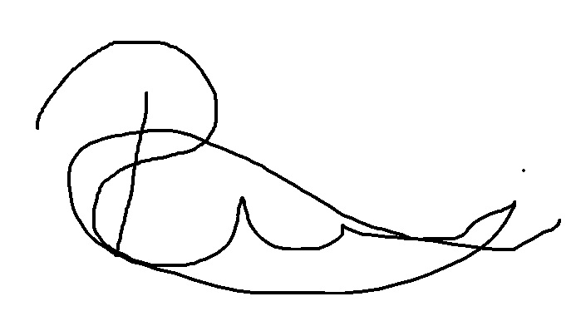
Approved by: | Date: | 11th September 2020
 | Name/Position: | Sarah Sheath, SOP Controller
 | Signature:
 | Date: | 14th September 2020

This Form will normally be reviewed every 3 years unless changes to the legislation require otherwise

Version History Log

This area should detail the version history for this document. It should detail the key elements of the changes to the versions.

Version | Date Implemented | Details of significant changes
1.0 | 27th July 2015
2.0 | 31st July 2017 | Two year review. No changes required
3.0 | 31st August 2020 | Change of author. Change of link to R&D website. No changes required
4.0 | 12th October 2020 | Change of format to the table. Added extra information.

Record of labels printed

Study Title…………………………………. EudraCT No…………………………………….

R&D Ref…………………………… Study label ID Ref……………………………

Drug, Form & strength……………………………………………………… Arm ……….………….

Ensure that you check the label(s) printed against the approved master label kept in section 2 of the pharmacy site file.
Date printed | Version  No.  Printed | No. of  Labels Printed | Patient Initials | Patient Trial ID number | Dispenser |  | Checker
 |  |  |  |  | Print Name | Sign | Print Name | Sign

