Master Label Form

Use this form in association with Pharm/S105 (Production and control of clinical trial labels)

IT IS THE RESPONSIBILITY OF ALL USERS OF THIS FORM TO ENSURE THAT THE CORRECT VERSION IS BEING USED

All staff should regularly check the R&D Unit’s website and/or Q-Pulse for information relating to the implementation of new or revised versions. Staff must ensure that they are adequately trained in the new procedure and must make sure that all copies of superseded versions are promptly withdrawn from use unless notified otherwise by the SOP Controller.

The definitive versions of all R&D Unit SOPs appear online. If you are reading this in printed form check that the version number and date below is the most recent one as shown on the R&D Unit website: https://www.research.yorkhospitals.nhs.uk/sops-and-guidance-/ and/or Q-Pulse

Form Reference: | Pharm/F33
Version Number: | 5.0
Author: | Rachel Spooner
Implementation date of current version: | 31st August 2020

Approved by: | Name/Position: | Poppy Cottrell-Howe, Pharmacy Clinical Trials Manager
Approved by: | Signature: | 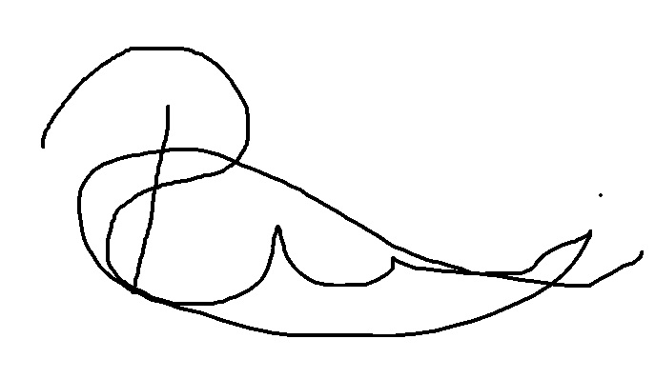
Approved by: | Date: | 3rd August 2020
 | Name/Position: | Sarah Sheath, SOP Controller
 | Signature:
 | Date: | 3rd August 2020

This SOP will normally be reviewed every 3 years unless changes to the legislation require otherwise

Version History Log

This area should detail the version history for this document. It should detail the key elements of the changes to the versions.

Version | Date Implemented | Details of significant changes
1.0 | 11th June 2009 | A Pharmacy document
2.0 | 1st February 2011 | Pharmacy document placed into template and cross referenced from Labelling SOP
3.0 | 27th July 2015 | Removal of references to the North and East Yorkshire R&D Alliance. Change of Author and SOP Controller. Change of title and format.
4.0 | 31st July 2017 | Two year review. No changes required.
5.0 | 31st August 2020 | Change of author. Change of link to R&D website. Removal of ‘Protocol number’.

MASTER LABEL FORM

Study Title:

R&D Ref:

EudraCT number: Study label ID Ref:

Drug, Form & Strength: Arm:

Sample of New Label:

Version No.

This New label was prepared by:

Print………………………………………………..

Sign………………………………………………..Date……………………………….

This New label was checked and authorised by:
(please sign label)

Print………………………………………………..

Sign………………………………………………..Date……………………………….

