Template master accountability log (double blind trial)

This template should be used in conjunction with
Pharm/S103 – Creating, reviewing and approving clinical trial accountability logs

IT IS THE RESPONSIBILITY OF ALL USERS OF THIS FORM TO ENSURE THAT THE CORRECT VERSION IS BEING USED

All staff should regularly check the R&D Unit’s website and/or Q-Pulse for information relating to the implementation of new or revised versions. Staff must ensure that they are adequately trained in the new procedure and must make sure that all copies of superseded versions are promptly withdrawn from use unless notified otherwise by the SOP Controller.

The definitive versions of all R&D Unit SOPs appear online. If you are reading this in printed form check that the version number and date below is the most recent one as shown on the R&D Unit website: https://www.research.yorkhospitals.nhs.uk/sops-and-guidance-/ and/or Q-Pulse

Form Reference: | Pharm/T36
Version Number: | 3.0
Author: | Cheryl Donne
Implementation date of current version: | 11th August 2020

Approved by: | Name/Position: | Poppy Cottrell-Howe, Pharmacy Clinical Trials Manager
Approved by: | Signature: | 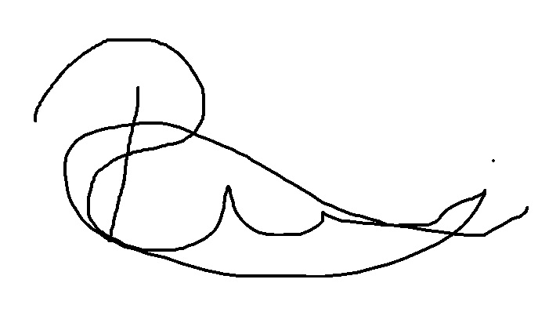
Approved by: | Date: | 14th July 2020
 | Name/Position: | Sarah Sheath, SOP Controller
 | Signature:
 | Date: | 14th July 2020

This Form will normally be reviewed every 3 years unless changes to the legislation require otherwise

Version History Log

This area should detail the version history for this document. It should detail the key elements of the changes to the versions.

Version | Date Implemented | Details of significant changes
1.0 | 29th May 2015
2.0 | 10th July 2017 | Two year review. No changes necessary
3.0 | 11th August 2020 | Change of link to R&D website. Change of author.

Name of clinical trial and protocol number (if applicable)
EudraCT number: Principal Investigator:
Description of drug name, strength, form and quantity

RECEIVED |  |  |  |  | DISPENSED |  |  |  |  |  | CRA CHECK
Date | Pack number | Batch number | Expiry date | Received by | Date | Patient initials | Trial ID number | Visit number | Dispensed by | Checked by | Sign and date

