Lone Working Visit Log

This form should be used in conjunction with
R&D/S98 – Lone Working

IT IS THE RESPONSIBILITY OF ALL USERS OF THIS FORM TO ENSURE THAT THE CORRECT VERSION IS BEING USED

All staff should regularly check the R&D Unit’s website and/or Q-Pulse for information relating to the implementation of new or revised versions. Staff must ensure that they are adequately trained in the new procedure and must make sure that all copies of superseded versions are promptly withdrawn from use unless notified otherwise by the SOP Controller.

The definitive versions of all R&D Unit SOPs appear online. If you are reading this in printed form check that the version number and date below is the most recent one as shown on the R&D Unit website: www.research.yorkhospitals.nhs.uk/sops-and-guidance-/ and/or Q-Pulse

Form Reference: | R&D/F113
Version Number: | 3.0
Author: | Kate Howard
Implementation date of current version: | 17th December 2019

Approved by: | Name/Position: | Lydia Harris, Head of R&D
Approved by: | Signature: | 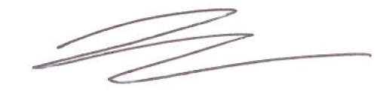
Approved by: | Date: | 19th November 2019
 | Name/Position: | Sarah Sheath, SOP Controller
 | Signature:
 | Date: | 19th November 2019

This Form will normally be reviewed every 3 years unless changes to the legislation require otherwise

Version History Log

This area should detail the version history for this document. It should detail the key elements of the changes to the versions.

Version | Date Implemented | Details of significant changes
1.0 | 5th November 2015
2.0 | 24th August 2017
3.0 | 17th December 2019 | Change of link to R&D Unit. Change of author.

Lone Working Visit Log

Code Word for danger: [Enter code word or phrase]
Date | Staff Member | Whereabouts | Time of Visit | Expected Completion Time | Visit Completed | Out of Hours Contact | Visit Car Reg | Other

Police Contact Number: 101 “Nurse may be in potential danger”

