Pharmacy Clinical Trials Wardlist Check Form

This form should be used in conjunction with
Pharm/S97 – Pharmacy Clinical Trials Wardlist Check Instructions

IT IS THE RESPONSIBILITY OF ALL USERS OF THIS FORM TO ENSURE THAT THE CORRECT VERSION IS BEING USED

All staff should regularly check the R&D Unit’s website and/or Q-Pulse for information relating to the implementation of new or revised versions. Staff must ensure that they are adequately trained in the new procedure and must make sure that all copies of superseded versions are promptly withdrawn from use unless notified otherwise by the SOP Controller.

The definitive versions of all R&D Unit SOPs appear online. If you are reading this in printed form check that the version number and date below is the most recent one as shown on the R&D Unit website: https://www.research.yorkhospitals.nhs.uk/sops-and-guidance-/ and/or Q-Pulse

Form Reference: | Pharm/F102
Version Number: | 4.0
Author: | Courtney Cole
Implementation date of current version: | 3rd September 2020

Approved by: | Name/Position: | Poppy Cottrell-Howe, Pharmacy Clinical Trials Manager
Approved by: | Signature: | 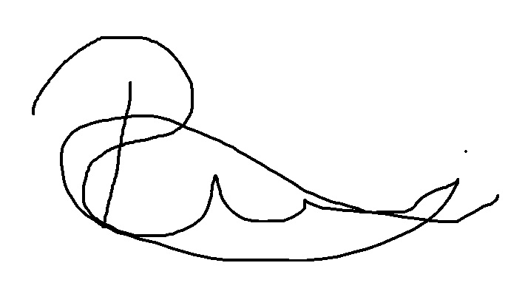
Approved by: | Date: | 6th August 2020
 | Name/Position: | Sarah Sheath, SOP Controller
 | Signature:
 | Date: | 6th August 2020

This Form will normally be reviewed every 3 years unless changes to the legislation require otherwise

Version History Log

This area should detail the version history for this document. It should detail the key elements of the changes to the versions.

Version | Date Implemented | Details of significant changes
1.0 | 20th August 2015
2.0 | 19th October 2015 | Number of rows increased
3.0 | 21st December 2017 | Changes to form to reflect review of current practice and change of author.
4.0 | 3rd September 2020 | Change of link to R&D website. Change of author

Wardlist check performed by | Date | Patient Name | Ward/  Unit | Trial name | Is the patient receiving active treatment? |  | Does patient have adequate supplies of study drug with them? |  | Is the study drug prescribed correctly? |  | Inform ward pharmacist/MMT and research team of any actions taken
 |  |  |  |  | No    No further action required | Yes   | No    Liaise with research team to obtain more supplies if needed | Yes   | No    Liaise with research team and/or ward pharmacist to ensure study drugs are prescribed if required | Yes   | Complete  
Tick if NO new patient(s) on clinical trials on this date
❑
The rest of the row does not need completing
 |  |  |  |  | No    No further action required | Yes   | No    Liaise with research team to obtain more supplies if needed | Yes   | No    Liaise with research team and/or ward pharmacist to ensure study drugs are prescribed if required | Yes   | Complete  
Tick if NO new patient(s) on clinical trials on this date
❑
The rest of the row does not need completing
 |  |  |  |  | No    No further action required | Yes   | No    Liaise with research team to obtain more supplies if needed | Yes   | No    Liaise with research team and/or ward pharmacist to ensure study drugs are prescribed if required | Yes   | Complete  
Tick if NO new patient(s) on clinical trials on this date
❑
The rest of the row does not need completing
 |  |  |  |  | No    No further action required | Yes   | No    Liaise with research team to obtain more supplies if needed | Yes   | No    Liaise with research team and/or ward pharmacist to ensure study drugs are prescribed if required | Yes   | Complete  
Tick if NO new patient(s) on clinical trials on this date
❑
The rest of the row does not need completing
 |  |  |  |  | No    No further action required | Yes   | No    Liaise with research team to obtain more supplies if needed | Yes   | No    Liaise with research team and/or ward pharmacist to ensure study drugs are prescribed if required | Yes   | Complete  
Tick if NO new patient(s) on clinical trials on this date
❑
The rest of the row does not need completing
 |  |  |  |  | No    No further action required | Yes   | No    Liaise with research team to obtain more supplies if needed | Yes   | No    Liaise with research team and/or ward pharmacist to ensure study drugs are prescribed if required | Yes   | Complete  
Tick if NO new patient(s) on clinical trials on this date
❑
The rest of the row does not need completing

