Trial Drug Recall Summary Sheet
This form should be used in conjunction with Pharm/S58

IT IS THE RESPONSIBILITY OF ALL USERS OF THIS FORM TO ENSURE THAT THE CORRECT VERSION IS BEING USED

All staff should regularly check the R&D Unit’s website and/or Q-Pulse for information relating to the implementation of new or revised versions. Staff must ensure that they are adequately trained in the new procedure and must make sure that all copies of superseded versions are promptly withdrawn from use unless notified otherwise by the SOP Controller.

The definitive versions of all R&D Unit SOPs appear online. If you are reading this in printed form check that the version number and date below is the most recent one as shown on the R&D Unit website: https://www.research.yorkhospitals.nhs.uk/sops-and-guidance-/ and/or Q-Pulse

Form Reference: | Pharm/F41
Version Number: | 5.0
Author: | Courtney Cole
Implementation date of current version: | 7th October 2020

Approved by: | Name/Position: | Poppy Cottrell-Howe, Pharmacy Clinical Trials Manager
Approved by: | Signature: | 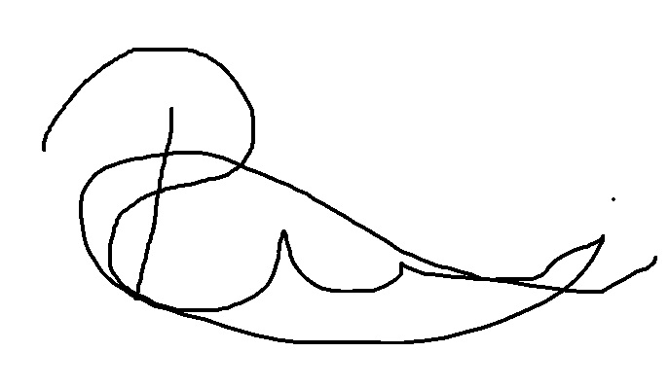
Approved by: | Date: | 3rd September 2020
 | Name/Position: | Sarah Sheath, SOP Controller
 | Signature:
 | Date: | 9th September 2020

This Form will normally be reviewed every 3 years unless changes to the legislation require otherwise

Version History Log

This area should detail the version history for this document. It should detail the key elements of the changes to the versions.

Version | Date Implemented | Details of significant changes
1.0 | 15th March 2010
2.0 | 23rd August 2013 | Removal of references to the North and East Yorkshire R&D Alliance. Change of SOP Controller. Change to title of form.
3.0 | 23rd November 2015 | Two year review done. No changes.
4.0 | 21st December 2017 | Change of author
5.0 | 7thOctober 2020 | Change of author. Change of link to R&D website.

TRIAL DRUG RECALL SUMMARY SHEET

PRODUCT DETAILS (drug name, form strength, pack size) | Batch number and expiry | RECALL DETAILS (class, reason or defect, timescale, test)

TRIAL TITLE and Eudract number | INVESTIGATOR | TRIAL SPONSOR

Date and time recall received: _____________________

Name and title of person leading the recall procedure: _________________________________

Section A - Initial assessment checklist

Has the above batch of medication been received for use in this trial? | Yes / No
Has all pharmacy stock been located and placed in quarantine?  Enter details in Section B | Yes / No
Has medication been returned from all clinical areas (if applicable)?  Enter details in Section C | Yes / No
Has the above batch of medication been dispensed to trial participants?  If ‘Yes’, please add patient details to Section D | Yes / No
Has the investigator been informed? | Yes / No
Who will be responsible for contacting the patients? (PI Name) Are they aware of next stage in process?

Refer to Pharm/S58 for actions required during the assessment of the IMP Recall. If the answer to any question is no, action will still be required to complete the IMP Recall.

Section B - Details of pharmacy stock identified

Pharmacy location | Details of medication placed in quarantine (quantity, batch number, expiry date) | Date/signature

Section C - Details of stock returned from clinical areas (wards/departments)

Clinical area location | Details of medication placed in quarantine (quantity, subject number, visit number, kit number etc) |  |  | Date/signature
Section D - Details of trial patients who have received the affected batch of medication
Please use the supplementary table on page 3 if more space is required to record patient details

Patient’s Name and trial number |  | Details of medication dispensed to patient (date, quantity, visit number, kit number etc) | Action taken, date and sign

Section E – Statement by the Research Nurse:

Patients contacted and asked to return affected medication YES / NO

These actions were completed by: (Sign and Date) ___________________________
File a photocopy of this form in Trial Master file and forward original to Pharmacy.
Section F - Statement by lead person:
Recall received by: (Sign and Date) ___________________________

All relevant areas have been checked YES / NO

Affected stocks have been returned to Pharmacy and quarantined YES / NO

Patients contacted and medication re- dispensed if appropriate YES / NO

These actions were completed by: (Date) ___________________________

Name & Signature of Recall lead |  | Date

Once all actions have been completed and documented, this report must be attached to a copy of the MHRA Drug Alert or Sponsor Drug Recall notification and filed in the pharmacy trial file together with the signed copy returned from the Research Nurse. If actioning a test recall, also attach Pharm/F49 – IMP Recall Test Form.

Supplementary page

Section D - Details of trial patients who have received the affected batch of medication

Patient’s Name and trial number | Details of medication dispensed to patient (date, quantity, visit number, kit number etc) | Action taken, date and sign

