IMP Recall Test Form
This form should be used in conjunction with Pharm/S58

IT IS THE RESPONSIBILITY OF ALL USERS OF THIS FORM TO ENSURE THAT THE CORRECT VERSION IS BEING USED

All staff should regularly check the R&D Unit’s website and/or Q-Pulse for information relating to the implementation of new or revised versions. Staff must ensure that they are adequately trained in the new procedure and must make sure that all copies of superseded versions are promptly withdrawn from use unless notified otherwise by the SOP Controller.

The definitive versions of all R&D Unit SOPs appear online. If you are reading this in printed form check that the version number and date below is the most recent one as shown on the R&D Unit website: https://www.research.yorkhospitals.nhs.uk/sops-and-guidance-/ and/or Q-Pulse

Form Reference: | Pharm/F49
Version Number: | 5.0
Author: | Courtney Cole
Implementation date of current version: | 7th October 2020

Approved by: | Name/Position: | Poppy Cottrell-Howe, Pharmacy Clinical Trials Manager
Approved by: | Signature: | 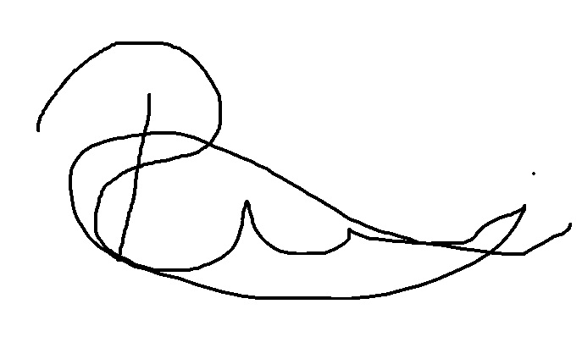
Approved by: | Date: | 3rd September 2020
 | Name/Position: | Sarah Sheath, SOP Controller
 | Signature:
 | Date: | 9th September 2020

This Form will normally be reviewed every 3 years unless changes to the legislation require otherwise

Version History Log

This area should detail the version history for this document. It should detail the key elements of the changes to the versions.

Version | Date Implemented | Details of significant changes
1.0 | 15th March 2010
2.0 | 23rd August 2013 | Removal of references to the North and East Yorkshire Alliance. Change of SOP Controller
3.0 | 23rd November 2015 | Two year review done. No Changes
4.0 | 21st December 2017 | Change of author
5.0 | 7th October 2020 | Change of author. Change of link to R&D website.

Follow Pharm/S58 to conduct this test
Consider the maintenance of the trial blinding
Check for any specific IMP recall instructions in the Pharmacy trial file before doing the test

Trial Name
EudraCT Number
Principal Investigator
Research Nurse
Sponsor
Date of test
Time of test
Details of IMP to be recalled during test (name, batch number, lot number, kit number, expiry dates).
Outcome of test
Actions to be taken to address any issues
Name of Pharmacy recall lead
Signature & date
Name of research nurse/PI
Signature & date
Please file in the relevant Pharmacy trial file after the test has been reviewed and any actions agreed.

